SIMATS ENGINEERING
ASSESSMENT TOOL 2: Scenario-Based Questions
COURSE NAME: COMPUTER VISION COURSE CODE: ITA0510
COURSE OUTCOME COVERED
CO2: Apply image enhancement and segmentation techniques for extracting meaningful regions from images. (BTL 3)
Assessment Tool Weightage: 50%
QUESTIONS: 5 Total Marks50 Duration :60 Minutes
Annexure A
Scenario-Based Questions
Code of Conduct:
I G.Dhanusha Sree(192325012) (Name / Reg No) certify that this submission is my original work and that I have adhered to the guidelines specified for this assessment.I understand that any violation of academic integrity rules will result in disciplinary action.
Signature of the student:
RUBRICS FOR CALCULATION:
Criteria | Weightage | Level 4 (Exemplary) | Level 3 (Proficient) | Level 2 (Developing) | Level 1 (Beginning) | Marks (100)
Understanding of Scenario | 20% | Demonstrates clear and complete understanding of the scenario and context | Shows good understanding with minor gaps | Partial understanding; misses key aspects | Misinterprets or fails to understand the scenario
Identification of Key Issues | 20% | Accurately identifies all relevant issues and factors involved | Identifies most key issues with minor omissions | Identifies limited issues; some irrelevant points | Unable to identify key issues
Application of Concepts | 25% | Applies appropriate concepts effectively to address the scenario | Applies concepts with minor errors | Limited or partially correct application | Unable to apply relevant concepts
Decision Making | 20% | Makes well-reasoned, logical decisions with strong rationale | Makes reasonable decisions with some justification | Makes weak decisions with limited justification | No clear decisions made or rationale provided
Clarity of Response | 15% | Response is clear, structured, and logically presented | Generally clear with minor issues | Somewhat unclear or poorly structured | Disorganized and difficult to understand

Scenario-Based Questions

1. Low Contrast Image
A grayscale image appears dull with very little difference between object and background intensities.
- Clearly interpret the scenario and explain the cause of low contrast.

A grayscale image appears dull because the intensity values of the object and the background are very similar. As a result, the image lacks clear distinction between different regions, making objects difficult to identify. Low contrast usually occurs due to poor lighting, improper camera settings, or limited dynamic range during image acquisition

- Identify all key issues affecting image visibility.

· Poor distinction between foreground and background.
· Loss of important image details.
· Edges become difficult to identify.
· Reduced visibility of textures and patterns.
· Difficulty in segmentation and feature extraction.
· Lower accuracy in image analysis and recognition tasks.

- Apply an appropriate enhancement technique to address the problem.
Histogram Equalization
Steps:
- Calculate the histogram of pixel intensities.
- Compute the cumulative distribution function (CDF).
- Map old intensity values to new values using the CDF.
- Generate the enhanced image with improved contrast.

- Justify your choice with logical reasoning.

Histogram Equalization is suitable because it redistributes pixel intensity values across the full intensity range (0–255). This increases the difference between dark and bright regions, making objects more visible without changing the actual image content. It is simple, computationally efficient, and widely used for grayscale image enhancement.

(e) Present your explanation in a clear and structured manner.

Problem
- Low contrast due to similar intensity values.
Issues
- Poor visibility
- Hidden details
- Difficult object detection
Technique
- Histogram Equalization
Advantages
- Enhances overall contrast.
- Improves visibility.
- Makes feature extraction easier.
Conclusion
Histogram Equalization effectively improves image quality by enhancing intensity distribution, making objects clearly distinguishable.
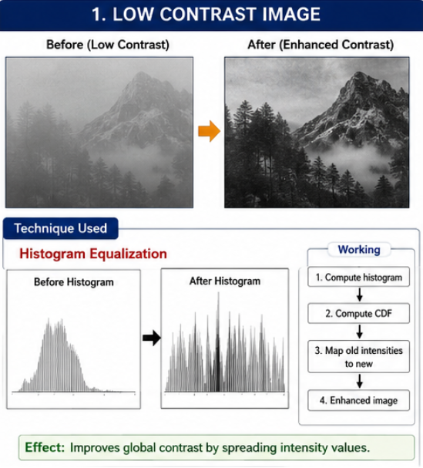

2. Uneven Illumination
An image captured under non-uniform lighting shows bright and dark patches.

- Interpret the scenario and explain the impact of uneven illumination.

The image contains bright and dark regions because lighting is not uniformly distributed across the scene. Some areas receive more illumination while others remain underexposed. This causes inconsistent brightness and makes image analysis difficult.

- Identify key factors causing intensity variation.
- Non-uniform lighting source.
- Shadows cast by surrounding objects.
- Different surface reflections.
- Camera exposure variations.
- Environmental lighting conditions.

- Apply a suitable enhancement method to normalize illumination.
Adaptive Histogram Equalization (CLAHE)
Procedure
- Divide the image into small regions.
- Perform histogram equalization on each region.
- Limit excessive contrast using clipping.
- Combine all regions smoothly.

- Justify your selected approach with reasoning.
CLAHE improves local contrast rather than global contrast. Unlike normal Histogram Equalization, it prevents over-enhancement in bright regions while improving darker areas. Therefore, it effectively normalizes uneven illumination and preserves image details.
(e) Provide a clear and well-structured explanation.
Problem
- Uneven lighting causes brightness variation.
Issues
- Bright and dark patches.
- Hidden details.
- Poor feature visibility.
Technique
- CLAHE
Advantages
- Enhances local contrast.
- Prevents over-brightening.
- Preserves image quality.
Conclusion
CLAHE is the most suitable technique because it improves visibility under varying lighting conditions without introducing excessive contrast.
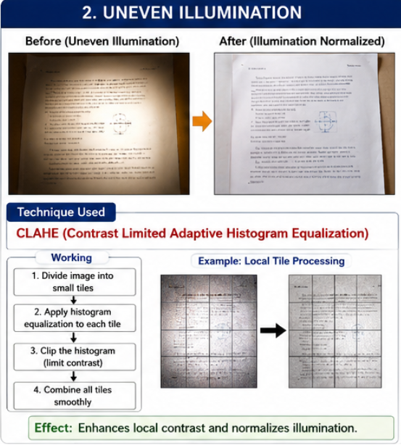
3. Salt-and-Pepper Noise
A scanned document contains salt-and-pepper noise affecting readability.
- Explain the scenario and characteristics of this noise.
Salt-and-pepper noise appears as randomly scattered white (salt) and black (pepper) pixels in an image. It commonly occurs during image transmission, sensor malfunction, or scanning. In scanned documents, this noise reduces readability and affects text recognition.

- Identify key issues impacting image quality.
- Random black and white pixels.
- Reduced readability.
- Distorted text and characters.
- Poor OCR performance.
- Difficulty in document analysis.

- Apply an appropriate filtering technique.
Median Filter
Procedure
- Select a small neighbourhood (3×3 or 5×5).
- Arrange neighbouring pixel values in ascending order.
- Replace the centre pixel with the median value.
- Repeat for every pixel.

- Justify why this method is more suitable than alternatives.
Median filtering removes impulse noise effectively while preserving image edges. Mean filtering blurs edges because it averages pixel values, whereas the median filter replaces noisy pixels without affecting surrounding edges. Therefore, it is the preferred method for salt-and-pepper noise removal.
- Present your response clearly and logically.
Problem
- Salt-and-pepper noise.
Issues
- Random noisy pixels.
- Poor readability.
- Reduced OCR accuracy.
Technique
- Median Filter
Advantages
- Removes impulse noise.
- Preserves edges.
- Improves document quality.
Conclusion
The Median Filter is the most effective technique for removing salt-and-pepper noise while maintaining image sharpness.
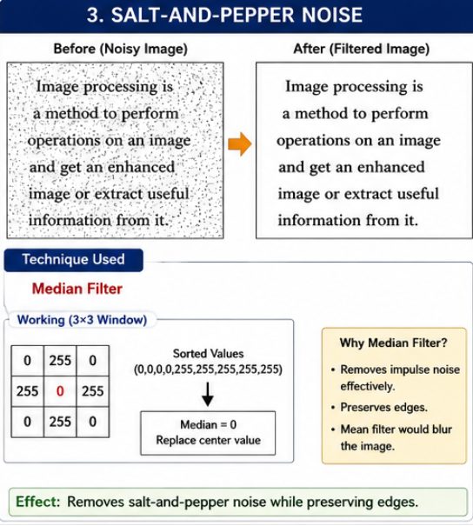
4. Blurred Edges
An image processed for noise removal appears overly smooth, causing edges to blur.
- Interpret the scenario and explain why edges are blurred.
After applying a smoothing filter to remove noise, important image edges become blurred. This happens because smoothing filters reduce both noise and high-frequency edge information.

- Identify key issues related to smoothing and edge loss.
· Loss of edge information.
· Reduced image sharpness.
· Poor boundary detection.
· Difficulty in object recognition.
· Lower segmentation accuracy.

- Apply an appropriate technique to restore edges.
Sharpening using Laplacian Filter
Procedure
- Detect regions of rapid intensity change.
- Apply the Laplacian operator.
- Add the sharpened result to the original image.
- Restore edge clarity.

- Justify your decision with clear reasoning.
The Laplacian filter enhances high-frequency components corresponding to edges. It restores sharpness lost during smoothing while maintaining overall image quality. It is computationally simple and highly effective for edge enhancement.

(e) Structure your explanation clearly.
Problem
- Blurred edges after smoothing.
Issues
- Edge loss.
- Reduced sharpness.
- Poor boundary detection.
Technique
- Laplacian Sharpening
Advantages
- Restores edges.
- Improves sharpness.
- Enhances object boundaries.
Conclusion
Laplacian sharpening effectively restores edge details and improves the visual quality of the image.

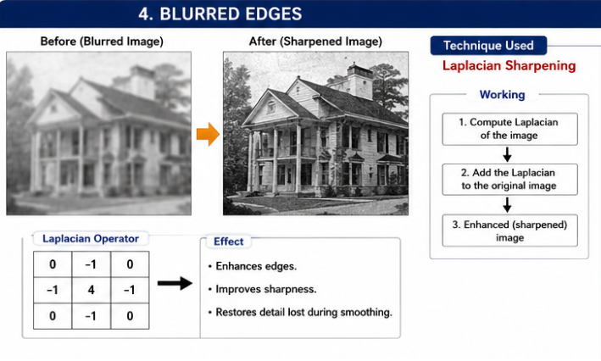
5. High-Frequency Noise
A satellite image contains fine-grained noise affecting feature visibility.
- Interpret the scenario and describe high-frequency noise.
A satellite image contains fine-grained random variations called high-frequency noise. This noise affects the visibility of land features, roads, vegetation, and buildings, making interpretation difficult.

- Identify the key issues affecting image clarity.
- Fine-grained random noise.
- Reduced image clarity.
- Hidden geographical features.
- Difficulty in feature extraction.
- Lower classification accuracy.

- Apply an appropriate frequency domain filtering method.
Low-Pass Filter (Gaussian Low-Pass Filter)
Procedure
- Convert the image to the frequency domain using the Fourier Transform.
- Apply a Gaussian Low-Pass Filter to suppress high-frequency noise.
- Preserve low-frequency image information.
- Perform the inverse Fourier Transform to reconstruct the image.

- Justify the choice of filter with reasoning.

High-frequency noise mainly exists in the higher frequency components of an image. A Gaussian Low-Pass Filter effectively removes this noise while minimizing ringing artifacts and preserving important image structures. Compared to an Ideal Low-Pass Filter, it provides smoother transitions and better visual quality.

(e) Present your answer in a clear and organized manner.
Problem
- High-frequency noise in a satellite image.
Issues
- Poor visibility.
- Feature distortion.
- Reduced classification accuracy.
Technique
- Gaussian Low-Pass Filter
Advantages
- Removes high-frequency noise.
- Produces smooth results.
- Preserves important image features.
Conclusion
A Gaussian Low-Pass Filter is the most appropriate frequency-domain method for reducing high-frequency noise while maintaining essential satellite image details.

